Lighting a room

Katie turns the light on so she can see.
Her dad is asleep in the chair.
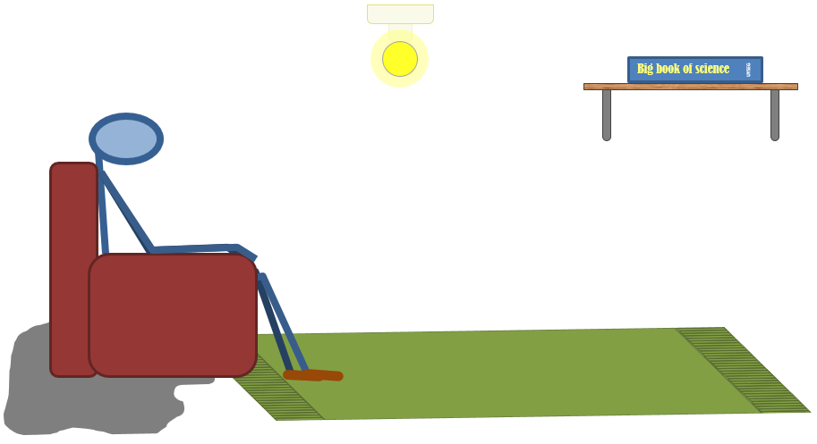

How does the bulb light the room?
Which of these statements do you think are right?
For each statement, tick (✓) one column to show what you think.
Places |  | I am sure this is right | I think this is right | I think this is wrong | I am sure this is wrong
A | Light moves in straight lines from the bulb
B | No light reaches behind dad’s chair where it is darker
C | Light keeps coming out of the bulb and bouncing off things
D | Light flows out of the bulb until it fills the room, then it stops moving

Physics > Big idea PSL: Sound, light and waves > Topic PSL1: Sound and light > Key concept PSL1.2: Characteristics of light
Diagnostic question
Lighting a room

Overview
Learning focus: | Light travels in straight lines at very high speeds.
Observable learning outcome: | Explain how light from a bulb illuminates a place.
Question type: | Confidence grid
Key words: | Light, travel, straight-line

What does the research say?
Allen (2014) describes how a few students imagine that light moves from a candle, say, to fill a limited space and then stays still. They may think that the light does not travel as far as the dark corners of a room.
Stead and Osborne (1980) also found that most students do not think of light travelling out very far from the source, particularly in day time. Perhaps because torches can be seen to illuminate and change the brightness of distant objects at night, but have no noticeable effect during the day. It has been found that about 40% of 13-15 year olds think that light travels different distances depending on whether it is night or day (Fethersonhough and Treagust, 1990).
In a study of 125 ten and eleven year olds, Anderson and Smith (1986) asked what happens when the light is turned on in a dark room. They found that fewer than 20% of students correctly chose the option ‘light keeps coming out of the lamp and bouncing off things’. Instead over 75% chose the answer ‘the lamp makes the room bright’. This answer does not specify a mechanism and is an incomplete answer that indicates students are not using a general understanding of light to interpret new situations, but instead are describing what they have experienced.
This question uses a confidence grid to check more thoroughly what students understand about how a bulb lights a room.
Ways to use this question
Students should complete the confidence grid individually. This could be a pencil and paper exercise, or you could use an electronic ‘voting system’ or mini white boards and the PowerPoint presentation.
If there is a range of answers, you may choose to respond through structured class discussion. Ask one student to explain why they gave the answer they did; ask another student to explain why they agree with them; ask another to explain why they disagree, and so on. This sort of discussion gives students the opportunity to explore their thinking and for you to really understand their learning needs.

Differentiation
You may choose to read the questions to the class, so that everyone can focus on the science. In some situations it may be more appropriate for a teaching assistant to read for one or two students.
Expected answers
Answers A and C are correct, B and D are wrong.
How to respond - what next?
Anderson and Smith (1986) found Answer D was held by only a small number of children. They are thinking of light as a material substance.
Answer B perhaps shows a partial understanding because the chair does block light from the lamp. However, light also bounces off other objects in the room and a small amount reaches behind the chair. Objects placed in the chair’s shadow will still be faintly visible.
If students have misunderstandings about how the bulb lights up every corner of the room, it can help to discuss how it does this with the whole class and then to give each student the opportunity to explain how it does so in their own terms. Some students may find it helpful to annotate a picture of the room. Working in pairs or small groups can encourage social construction of scientific ideas through dialogue.
Those that understand how the bulb lights the room can be challenged to explain what happens when the light is turned on during the day.
The following BEST ‘response activity’ could be used in follow-up to this diagnostic question:
- Response activity: Day light
Acknowledgments
Developed by Peter Fairhurst (UYSEG), from an idea in Childrens' conceptions of light and colour (Anderson and Smith, 1986).
Images: UYSEG
References
Allen, M. (2014). Misconceptions in Primary Science, Second edn Berkshire, UK: Open University Press.
Anderson, C. W. and Smith, E. L. (1986). Childrens' conceptions of light and colour: developing the concept of unseen rays. Annual meeting of the American Educational Research Association. Montreal, Canada.
Fethersonhough, T. and Treagust, D. (1990). Students' understanding of light and its properties following a teaching strategy to engender conceptual change. Annual meeting of the American Educational Research Association. Boston.
Stead, B. F. and Osborne, R. J. (1980). Exploring students' concepts of light. The Australian Science Teachers' Journal, 26, 84-90.

